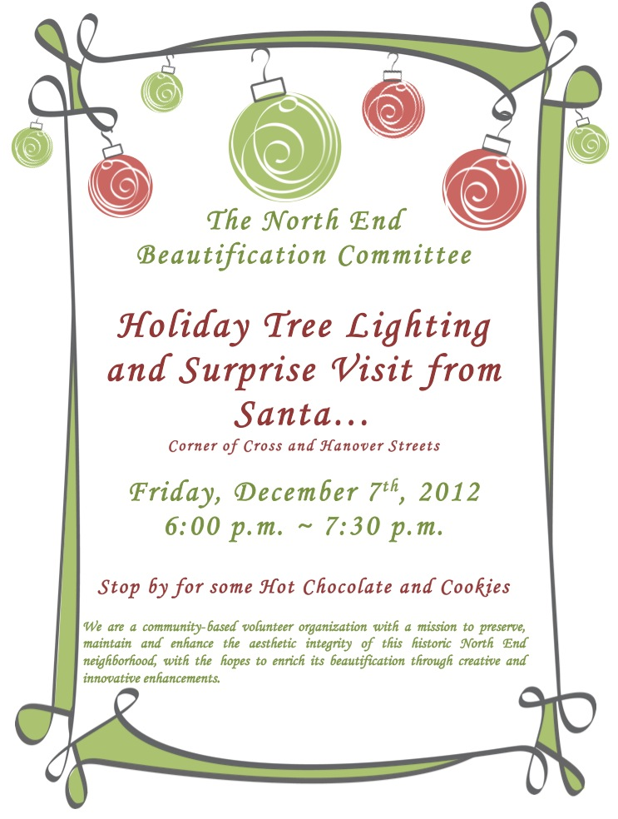

AFGE Local 1395 Presents:

A 2015 Holiday Extravaganza

**When:** Saturday, December 5

6:00 pm to midnight

**Where:** Quality Inn at Midway

7353 S Cicero, Chicago, IL

Dinner with Open Bar

DJ and Entertainment

Raffles and Prizes

Cost: Union Member - $15.00

Union Member + ONE Guest - $40.00

*Hotel Discounts Available

For More Information: 312-575-5615

Tickets available: Noon to 1pm in the Union Office

from Wednesday through Friday of each week starting on Thurs, Nov 5 through Fri, Nov 20